In this blog I will talk about the steps and activities required to delete the Initial Load. Surprised why deletion? Don’t be.. It is a very normal process where we may need to have a requirement of deleting Initial load during test phases. If there are some processes on enhancements, which were supposed to be successful during initial load and those, is failed in testing then what? You will say that those can be tested during near time replication, not necessarily.

Technically Initial Load and real time replication works in a complete different way in Central Finance, although they have same purpose to pull data from source and post in S/4HANA but the logic, posting programs, mechanism is completely different so anything related to initial load needs to be tested in initial load run.

Therefore, when something goes wrong with initial load or test results are not successful then you have **TWO** options:

1. Clean out your test system by refreshing it will clean client
2. Delete Initial Load and posted data

Option one is easy but it requires support from basis team and may also ask for some cost & rework but option 2 is purely with functional team where they can delete the initial load. So what are the steps and requirements:

Activities in Central finance system:

**FI documents Load deletion-**

Go to CFINIMG > Delete Initial Load Data

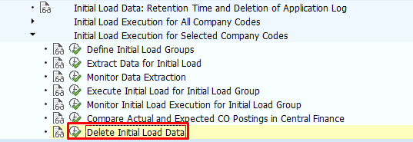

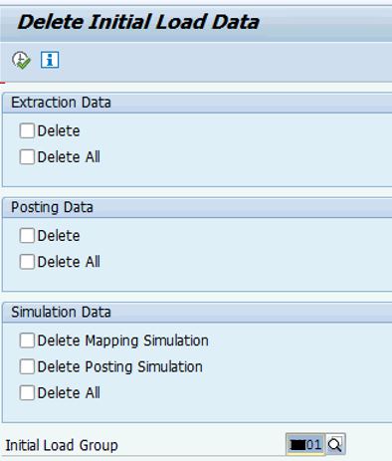

Or in SE38, run this program – ***RFINS_CFIN_CLEAR_INIT_LOAD***

In this area, you can trigger the deletion of initial load data which was created during the posting step of the initial load.

* Select **delete** if you want to delete this data for a separate combination of logical system and company code or for a separate initial load group only.
* Select Delete All if you want to delete all existing data which was created during posting step of the initial load for all combinations of logical system and company code or initial load group.
* Don’t forget to check the below tables:
  + Transfer Table – CFIN_ACCHD
  + Transfer Table for line items – CFIN_ACCIT

This will delete the FI Initial Load but what about the partial postings, which are already done and posted in table ACDOCA, of course you need to delete those as you will plan to run the whole initial load again and if the existing postings are present in table there will be duplicate postings.

If you want to delete posted documents, you can do this using the transaction **FINS_CFIN_DOC_DELETE**(Central Finance: Deletion of FI Documents).

**CO Documents Load deletion**

Use this transaction to reset CO Initial Load – **FINS_CFIN_CO_DOCS_IL_RESET**

If some documents are already posted then those also needs to be deleted in the Central Finance system.

Use this transaction to delete the CO documents which are already posted – ***FINS_CFIN_CO_DOC_DEL – CO***

**Cost Object Load deletion**

Follow below steps to delete the AUFK load and created data

* CFIN_CO_MAPPING_DEL – Delete Internal Orders from table AUFK
* OK05 – Delete CO orders
* KONK – Reset number ranges for orders
* KANK – Reset number ranges for CO documents

After this process, the AIF messages stuck in processing and logs from AIF needs to be deleted.

***Transaction – /n/AIF/PERS_DEL***

Select an interface, period, & status of the messages. This transaction can delete AIF messages of any status. To carry out a complete reset, delete all AIF Messages in particular interface. Depending on the number of messages planned to be deleted, it is recommended to run the report in the background.

All these activities will clean up the S/4HANA Central Finance system. However job is still not done, you need to delete the logs in the source system as well. If you don’t delete those then the new initial load will not be started as log table already have data.

In ***Program – RCFIN_DEL_MIG*** the entry needs to be deleted. Ensure you delete the right entry as this will have all the entries which you may not want to delete (other initial loads)

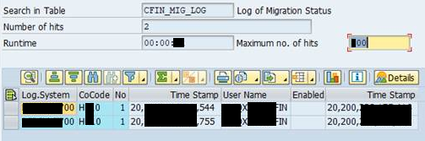

This activity can also be completed from S/4HANA systems if RFC connections are set up correctly using ***Transaction  – FINS_CFIN_DEL_SRC***

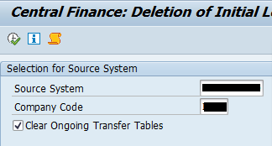

Once all these activities are completed, you need to work on the reason due to which you delete initial load. It may be wrong data, failure in custom objects or anything based on the design.

When you are ready again, you can start the initial load with the same process, sequence & steps you have executed it last time.

Happy reading…